RELATIONSHIP FUNCTIONS
NOTE: By using this function, we can manage and utilizing the relationship between tables.
The categories are
- Related 2)LOOKUPVALUE 3) Relatedtable 4) Userelationship
Input Data: In this we are taken 2 tables i.e., 1) customer 2) order
1) 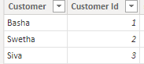 2) 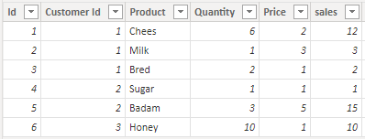

1)RELATED: By using this function we can get the column from another table.
Syntax: RELATED(<column>)
NOTE: If we want to apply this function on any dataset, dataset must be satisfying these following rules,
1)Must and should relationship be required between the dataset.
2)Must and should be satisfy of any one following the cardinality,
“One to one” means a row in table A can have only one matching row in table B.
“One to many” means a row in table A can have multiple rows matching in table B.
“Many to one” means multiple rows in table A can have only one matching row in table B.
Difference between RELATED and LOOKUPVALUE:
This is similar to “LOOKUPVALUE” function but difference is there is no required any rules for “LOOKUPVALUE” function, but the result will give same.
If a relationship does not exist, we must create a relationship between the dataset.
If any column datatype and column name are same then automatically power bi create a relationship, otherwise go to “manage relationship” and set the relationship manually between the dataset.
This function can apply in “new column”.
Before we can apply this function first of, we can check it the relationship is there or not, if it is there next applying this function.

Scenario: Now I want to get the “customer” column from customer table in to “order” table.
Dax Function: Customer Name = RELATED(customer[Customer])

Output:
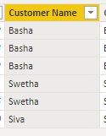

2)LOOKUPVALUE: This is similar to Related function. By using this function, we can get the column name from another table.
NOTE: But in this no certain rules i.e., not compulsory for relationship between dataset and not to satisfy any one cardinality.
Related and Lookupvalue both functions are given same result.
Syntax: LOOKUPVALUE(<result_columnName>,<search_columnName>,<search_value>[, <search2_columnName>, <search2_value>]…[, <alternateResult>])
Dax Function: Customer Name Lookup = LOOKUPVALUE(customer[Customer],customer[Customer Id],'order'[Customer Id])
NOTE: Lookupvalue(<result_columnname>,<search_columnname>,<search_columnname>)
<result_columnname>-give what do u want to display that column name
<search_columnname1>,<search_columnname2>---In this we can provide common column in that particular dataset.
Output:
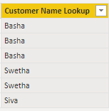

3)RELATEDTABLE: By using this function, we can get the table from another table.
This function is shortcut for CALUCATETABLE function.
NOTE: In RELATED function based on column but in RELATEDTABLE based on table.
Syntax: RELATEDTABLE(<tableName>)
NOTE: I want to create total sales of sum, that’s why we can use “Measure”.
Dax Function: Total sales of sum = SUMX(RELATEDTABLE('order'),'order'[sales])
Output:
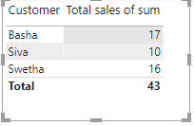

4)USERELATIONSHIP: By using this function, convert from inactive relationship to active relationship between the dataset.
NOTE: If a relationship is inactive, we can must convert a relationship from inactive to active by using this function
If a relationship is active then also apply this function.
Syntax: USERELATIONSHIP(<columnName1>,<columnName2>)
NOTE: I want to calculate sum of sales, that’s why we can use in that measure only.
Dax Function: userrelatioship = CALCULATE(SUM('order'[sales]),USERELATIONSHIP(customer[Customer Id],'order'[Customer Id]))
Output:

